**Flight Booking System for Airlines (Java Web Application)**

This flight booking system will include all the functions related to flight search, booking, customer data, type and dates etc. It will be a fully responsive webpage built with the compilation of Frontend(UI) and Backend(Spring) connected with MongoDB and MySQL databases.

**Technologies to be used**

* **Frontend:** HTML, CSS, JavaScript, Angular
* **Backend:** Spring core, Spring Microservices, Spring Boot, Spring MVC, Spring Rest
* **Database:** MongoDB, MySQL

**Roles**

Following roles are implemented:

* Flight Admin
* Passenger

**Modules**

* Flight Details
* Passenger Details
* Booking Details
* Airport-Details
* User-management-service

**Microservice Architechture**

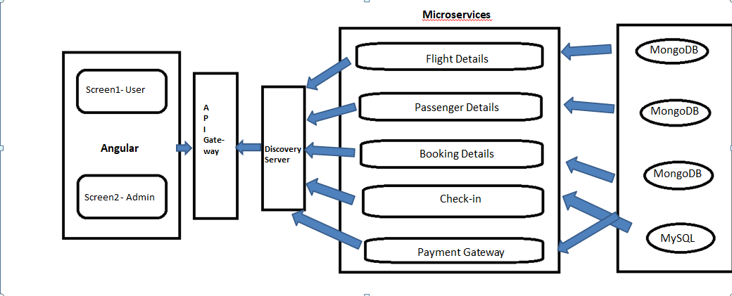

User Management